# Push2Play Notification Maintenance

**Statement of confidentiality**

This document is for the sole and exclusive use of Lotto NZ. The information contained is confidential.

Version history

| Date | Version | Change | Author |
| --- | --- | --- | --- |
| 08/04/2016 | 0.1 | Initial draft created | Johnson Mar |
| 11/04/2016 | 0.2 | Changes based on outcome of discussionsin today’s kick off meeting. |  |
| 14/04/2016 | 0.3 | Changes based on final UI Design specs sent on 13/04. Changes include images and changes to text are highlighted in blue. |  |
| 15/04/2016 | 1.0 | Baselined to Version 1.0 |  |

# Overview

This chapter describes the process for updating the user’s Push2Play (P2P) notification record. It addresses both the front end functionality and back end processes that occur when a user updates their record.

Any changes to the user’s P2P notification requires the user to have logged in first.

The Push 2 Play (P2P) database tables and their columns are described in the P2P design document “Push2Play Detailed Design” – the latest version can be obtained from Ferdinand Contreras at Lotto NZ.

**Scope:**

* In-scope:
* Requirements defined in this document
* Out-of-scope:
* Ability to pre-populate phone number for a logged in user. This will be addressed separately in a change request.

**Important:**

The only scenario where the initial notification is retained in the P2P database is when the user edits the favourite used for the notification. Every other scenario as decribed in item 3 below will result in a change to the Status of the prior notification to ‘Stopped’ as there can only be one active notification.

**Wireframes:**

No notification created

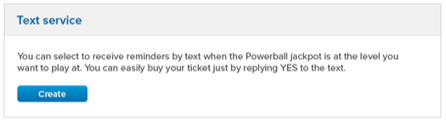

Dip notification created

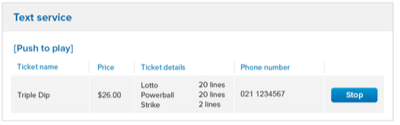

Favourite notification created

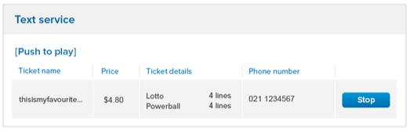

Note:

The words [Push to Play] are no longer required following discussions with Leona. Please ignore the wireframe representation.

# Create Notifications Maintenance Page

A user must be able to stop [receiving] a notification. This is achieved by the user navigating to a dedicated section [Text Service] within the My Account > My communications > Services page.

* If no notification has been created for P2P, the following is displayed to the user:
* [the words] “You can select to receive reminders by text when the Powerball jackpot is at the level you want to play at. You can easily buy your ticket by replaying YES to the text”
* This message is no longer visible once the user has created a notification
* Create button
* Clicking on the create button directs the user to the P2P landing page
* If a notification has been created for P2P, the following is displayed to the user:
* ~~(the words) [Push to play]~~ [this is no longer applicable according to Leona]
* Ticket name
* Price
* Ticket details
* Phone number
* Stop button
* Clicking on the Stop button would result in:
  + - Removes the notification from this section (if user confirms the stop process)
    - then displays the following as defined above [no notification]:
* [the words] “You can select to receive reminders by text when the Powerball jackpot is at the level you want to play at. You can easily buy your ticket by replaying YES to the text”
  + - * Create button
    - This stop process will update the back end systems as defined in item 4.3 below.

# Edit Favourites

This scenario implies amending the favorite [that is on record in the P2P notification pages] and can be either of the following:

* name of the favorite
* the numbers on the lines or
* the number of lines
* adds / removes Strike

In either of the 2 scenarios, user is required to navigate to the Lotto > Favourites landing page.

# User amends favourite name

* User clicks on the name of the favourite and can change it accordingly
* This updates the name in the notification record in their My account > My communications > Services page
* An update is also made in the following back end systems:
* P2P App
* P2P database
* The update to the backend systems requires the following information for correct identification and mapping:
* Id
* [esi] User Id
* Favourite name

# User changes the lotto numbers in one or more line(s) without changing the wager amount:

* User clicks on the edit icon
* deletes <x> lines the user wants replaced
* adds <x> lines the user wants to play either manually or through Autopick

# User amends the number of lines in the favourite and/or adds/removes Strike which changes the wager amount:

* User clicks on the edit icon
* User either deletes some of the lines or adds to those lines and/or
* User either deletes some of the strike lines [if added previously] or adds Strike lines which changes the wager amount for that favourite
* This updates the wager value in the notification record in their My account > My communications > Services page
* An update is also made in the following back end systems:
* P2P App
* P2P database
* The update to the backend systems requires the following information for correct identification and mapping:
* Id
* [esi] User Id
* Favourite name
* Wager amount

# Alternate scenarios:

As mentioned earlier, the following scenarios will result in a change to the Status for the notification in the P2P database from ‘Active’ to ‘Stopped’ with the exception of Close Account

* Change game type
* Change cell phone number
* Stop Notification
* Close Account

Multiple notification record(s) can be created in the P2P App and P2P database for 2 of the alternate scenarios defined above:

* Change game type
* Change cell phone number

# Logged in user changes the favourite or dip game type or cell phone number:

* Logged in user can either navigate to the Notifications Maintenance page in My Account [and clicks on Create] or to the P2P landing page to create another notification
* User (if in the My Account page is redirected to the P2P landing page and) proceeds to create a notification in accordance with process defined in the latest Push2Play DLR Opt In Process Spec
* The previous notification in the My Account page is deleted
* A new notification will be created in the My Account page
* The ‘Active’ notification on record in the P2P App and P2P database will be retained with the status changed to “Stopped’
* A new notification will be created in the P2P App and P2P database with the status set to “Active’

# Not logged in user changes the favourite or dip game type or cell phone number:

* User who has yet to log in navigates to the P2P landing page to create another notification
* User proceeds to create a notification in accordance with process defined under Chapter 3 of the latest Push2Play DLR Opt In Process Spec
* The previous notification in the My Account page is deleted
* A new notification will be created in the My Account page
* The ‘Active’ notification on record in the P2P App and P2P database will be retained with the status changed to “Stopped’
* A new notification will be created in the P2P App and P2P database with the status set to “Active’

# User stops the notification

* User can request to stop receiving notifications via the following two ways:
* Logged in user navigates to the Notifications Maintenance page in My Account and clicks the Stop button next to the notification
* User replies with a ‘Stop” SMS from the cell phone that is registered to their notification
* Notification is removed from their Notifications Maintenance page
* The update to the back end can be processed at any time regardless of what the cut-off time is and requires the following input:
* Cell phone number
* message
* The status of the notification is changed to ‘Stopped’ in the following back end systems:
* P2P App
* P2P database

# User closes their account

* Loggred in user navigates to their My Account page
* User clicks on “Close Account’
* User provides [optional] feedback and enters their password
* User clicks on Save changes
* The status of the notification in the back end systems is not changed as a result of this.